OOP or Object oriented Programming is a paradigm that utilize objects and their interactions to develope program and application. There are 4 pillars that make up the foundation of OOP. These are encapsulation, inheritance, polymorphism and abstraction, combine and they will define how to structure a program utilizing objects that contain both code and data, promoting reusability and scalability.

Encapsulation

Encapsulation binding the data and functions within the objects (Raut 2020), manipulating the data and keeping it safe from outside interference. Encapsulation groups related properties and methods inside an object can be control through access specifiers like public or private, providing objects with the ability to hide their internal representation, strengthening security and integrity.

Inheritance

Inheritance can create new classes know as subclasses or derived classes that taken on the traits and characteristics of the classes exist before it aka base classes. This allow common attributes and methods to be defined in baseclasses and inherited by many subclasses, making the code extremely reusable. In the end, this help reduce the complexibity, duplication and improves scalability

Polymorphism

Polymorphism enables objects of various classes to respond differently to the same method. It eliminates the need to pick between classes during compilation and allows you to code for base functionality rather than individual types. Polymorphism encourages generalizing interfaces and writing code that can interact with multiple types in the background.

Abstraction

Abstraction involve hiding unnecessary implementation details and exposing only essential information through abstract interfaces. It distinguishes between the logical architecture of objects and the specifics of how they are implemented in code. It enables developers to concentrate on the fundamental characteristics and actions of objects while concealing unnecessary data. This allows higher-level functionality to operate with objects without knowing how they are made under the hood. Focus shifts from low-level details to working at a conceptual problem-solving level, improving reusability.

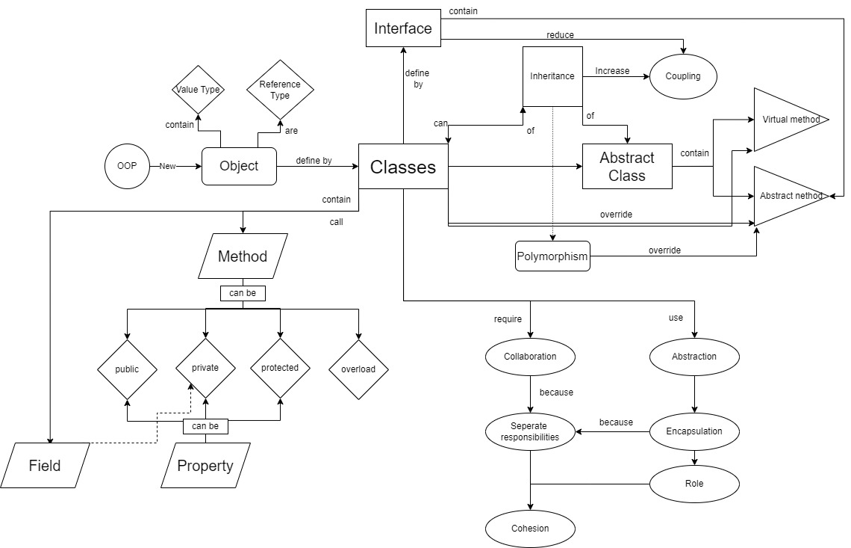These four pillars together constitute the cornerstone of object-oriented design concepts, which make systems more modular, reusable, extensible, and maintainable. By understanding and applying these OOP principles, developers may construct software systems that are scalable, maintainable, and robust.

REFFERENCE

Raut, R 2020, Research Paper on Object-Oriented Programming (OOP), IRJET, International Research Journal of Engineering and Technology (IRJET).